Module 1 – Week 1
Testing the client-server relationship
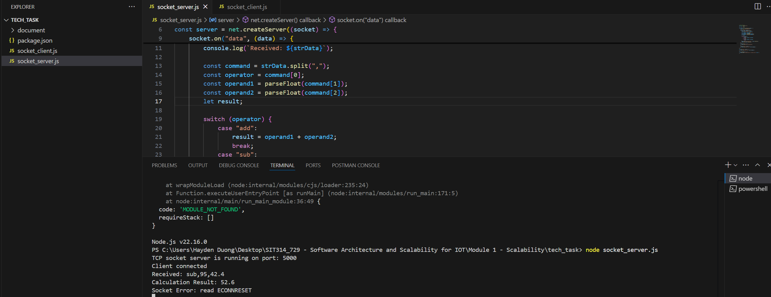
Picture 1 - Server-side result.

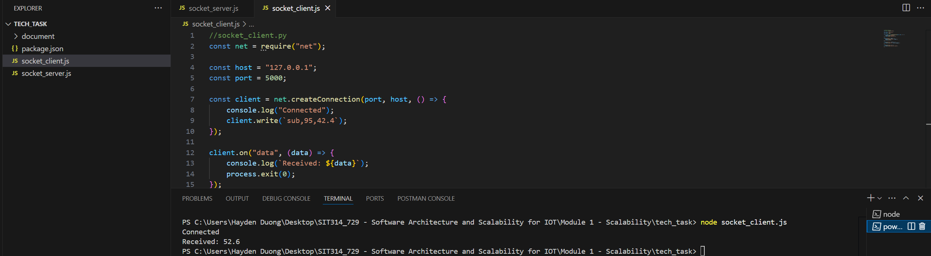
Picture 2 – Client-side result.

Experiment with code
A/ The interval of sending the data (repeat the comment every 2 seconds)
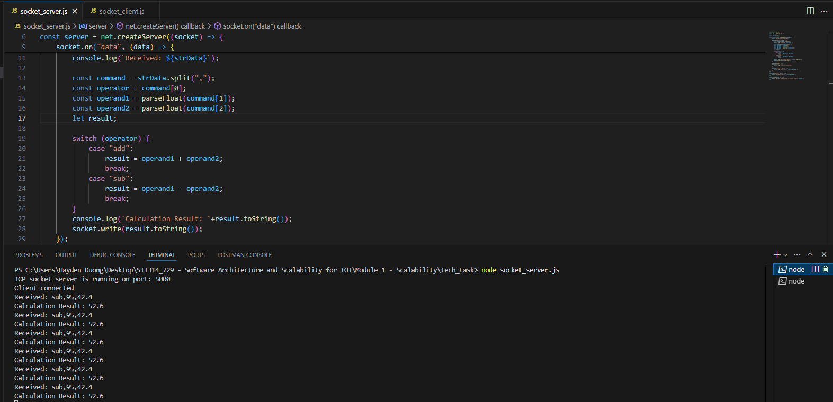
Picture 3 – Result from Server-side.
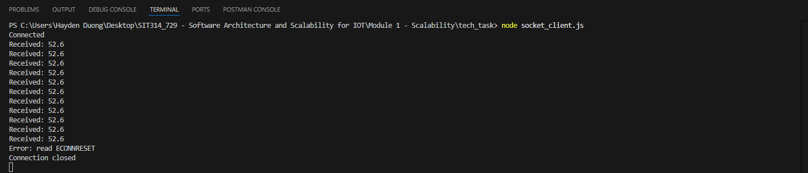
Picture 4 – Result from Client-side.

B/ Modify the server to support different calculations
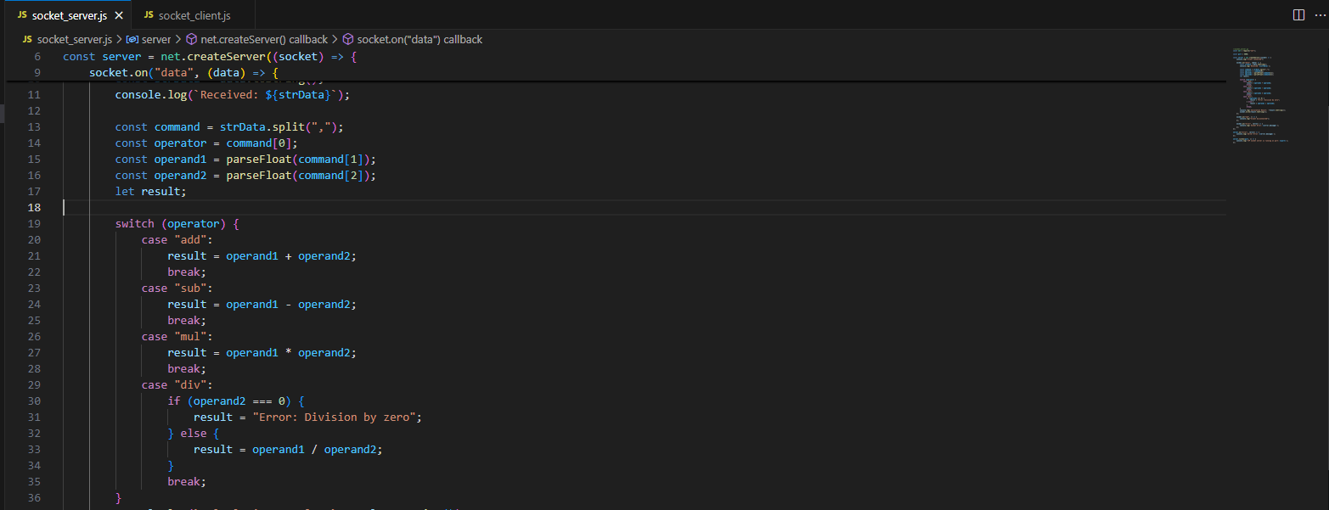
Picture 5 – Code-addition to socket_server.js
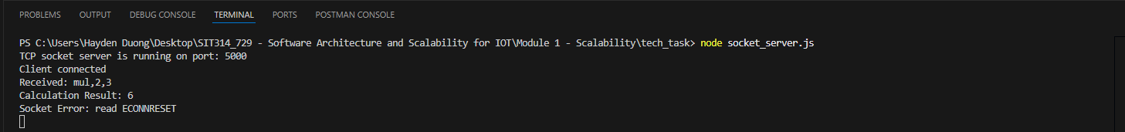
Picture 6 – Result from Server-side
Picture 7 – Result from Client-side

C/ Modify the client code so it reads a random number and sends it as part of the calculation
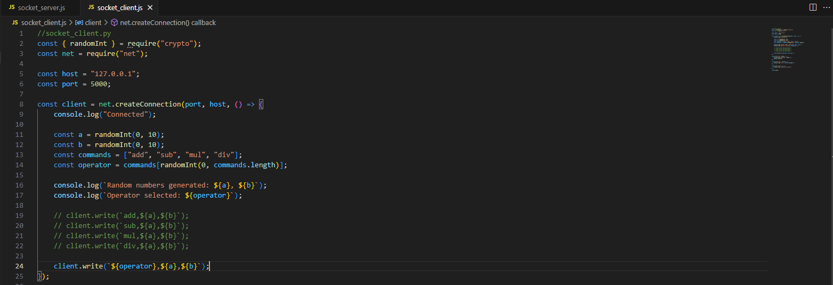
Picture 8 – Code addition & modification to socket_client.js

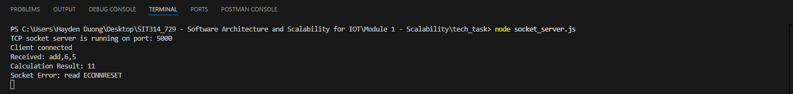
Picture 9 – Result from Server-side

Picture 10 – Result from Client-side

D/ Number of clients
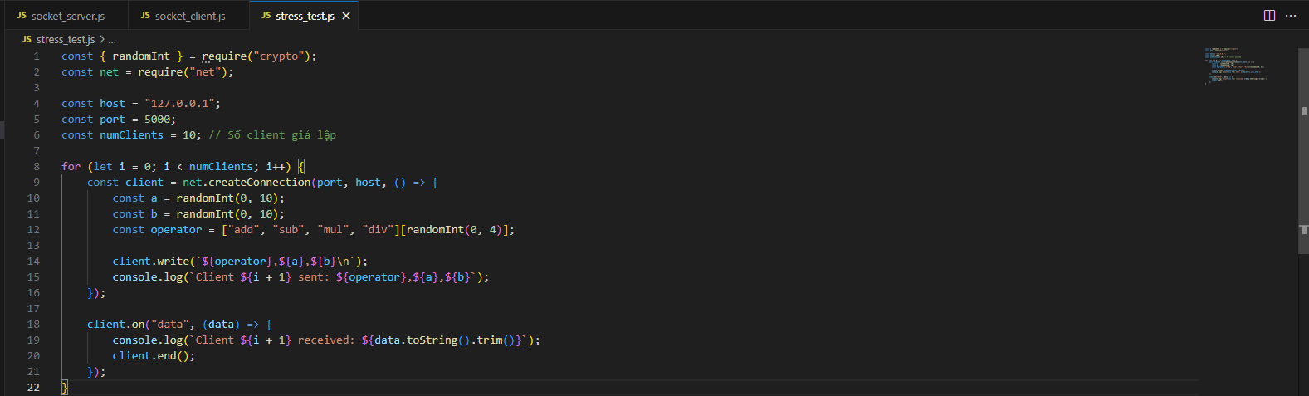
Picture 11 – Created a new JS file called stress_test.js to simulate several clients are connecting to socket_server.js (code suggested by DeepSeek)

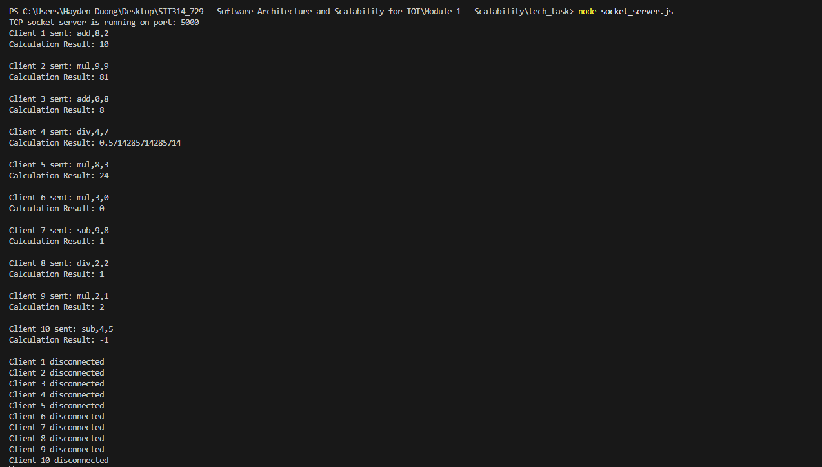
Picture 12 – Result from Server-side
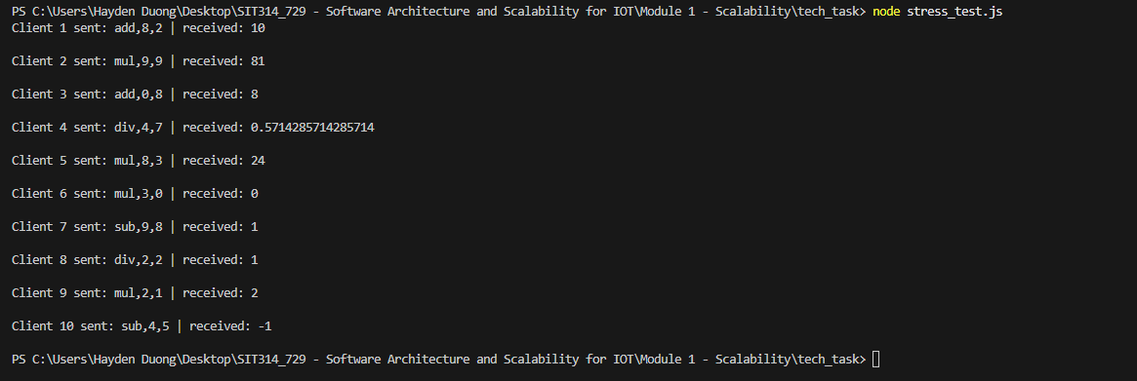
Picture 13 – Result from Client-side

E/ Connect between other computers (need to share stress_test.js for other group members to achieve different IP addresses display in the server-side terminal – tested with)
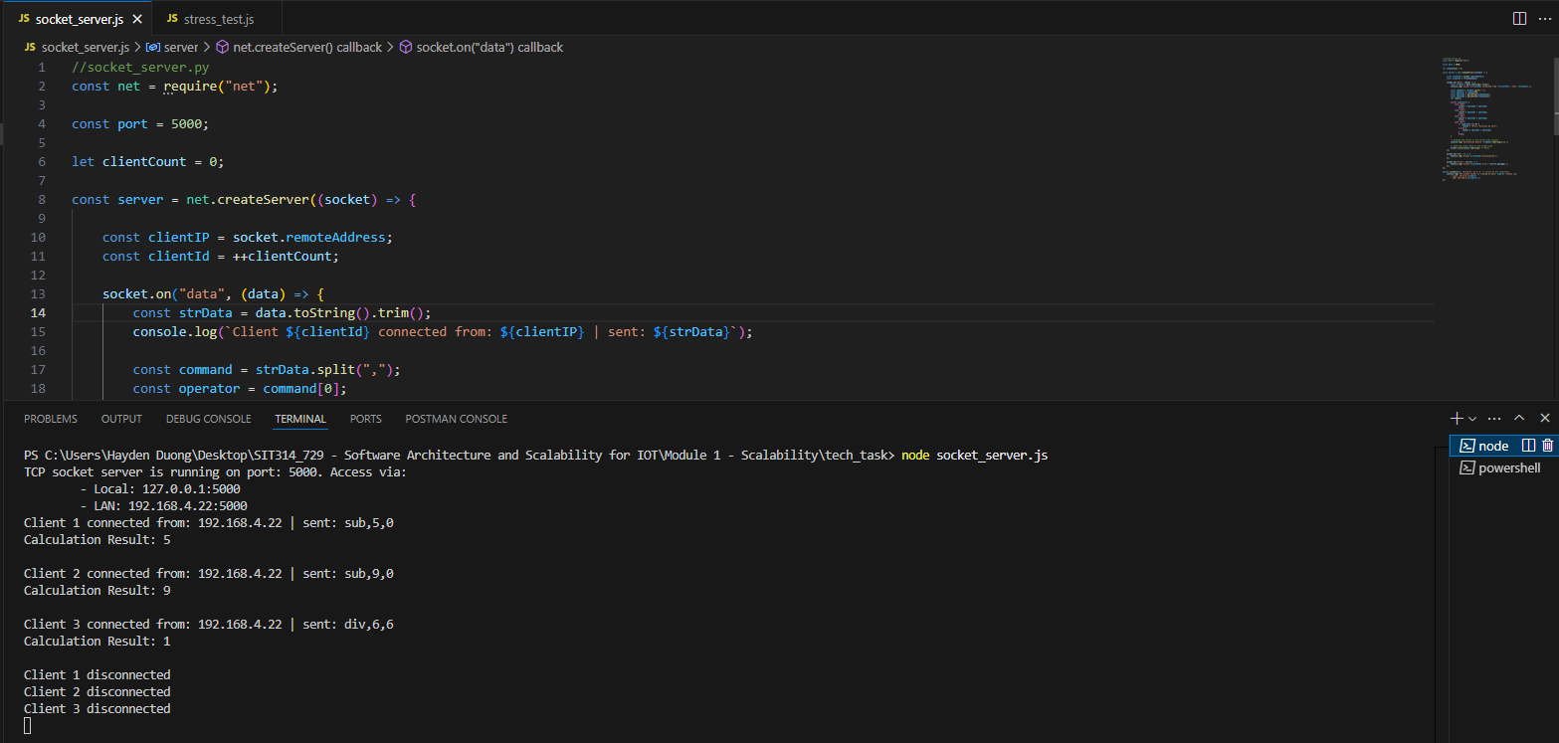
Picture 14 – Result from Server-side
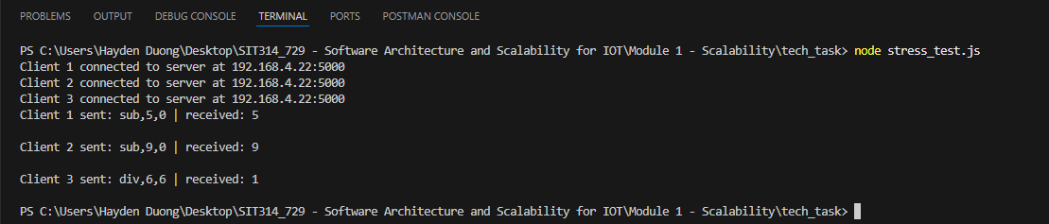
Picture 15 – Result from Client-side

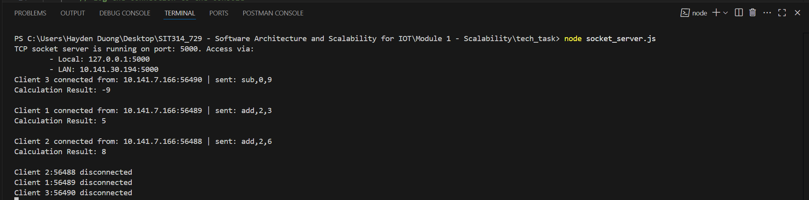
Picture 16 – Result from the Server-side when another team member used my “stress_test.js” to test connection to the “socket_server.js”

F/ Put Pressure on Server
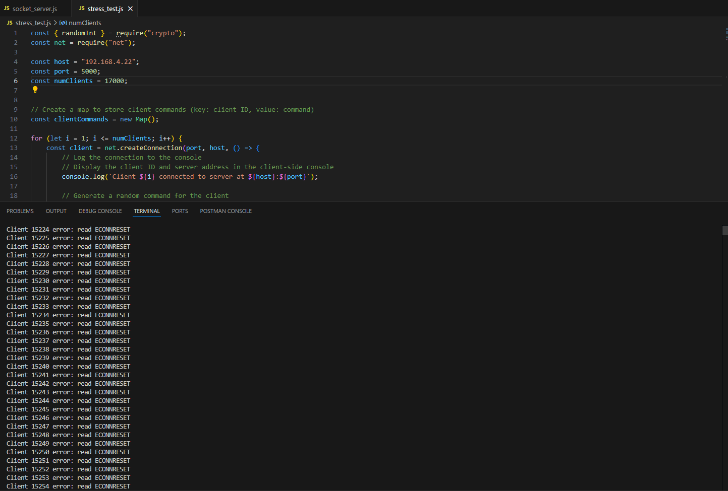
Picture 16 – Result from Server-side
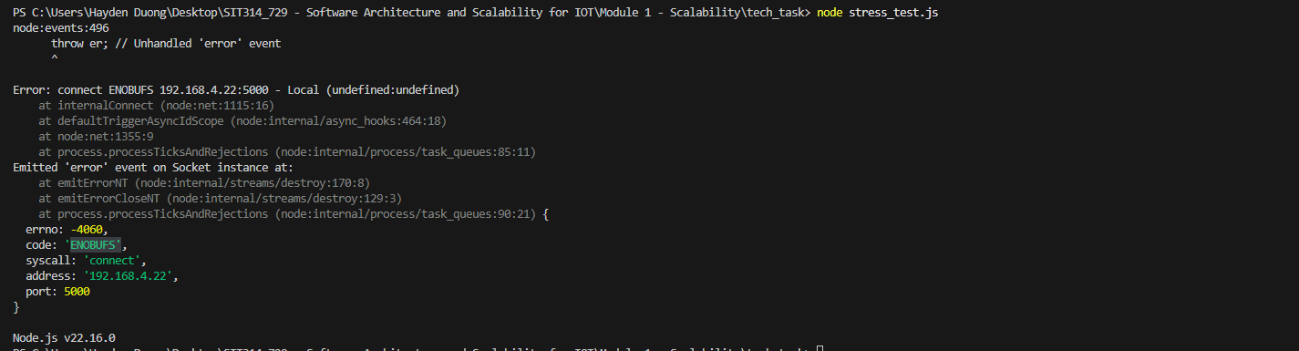
Picture 17 – Result from Client-side.

